Navigation:
Self Service > Faculty Center

Page | Action(s) to be taken
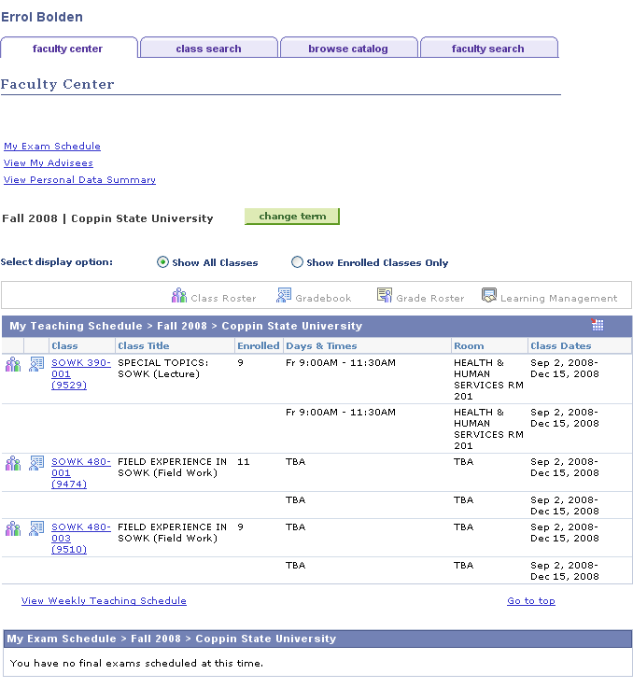 | - Click
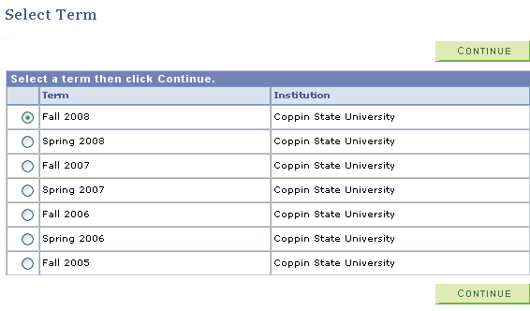 | - Select the Term for which you wish to view your class rosters by pressing on the radio button beside the term in the listing.  - Click
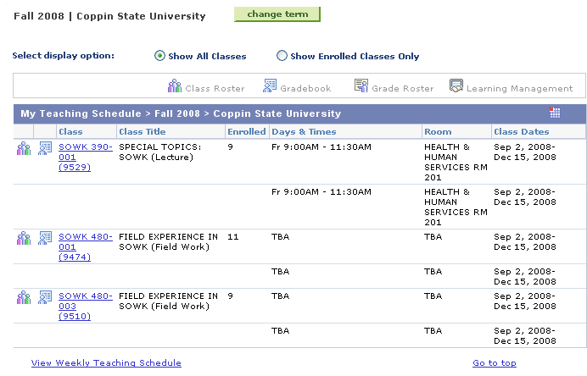 | - Click beside the class section to select the roster you wish to view.
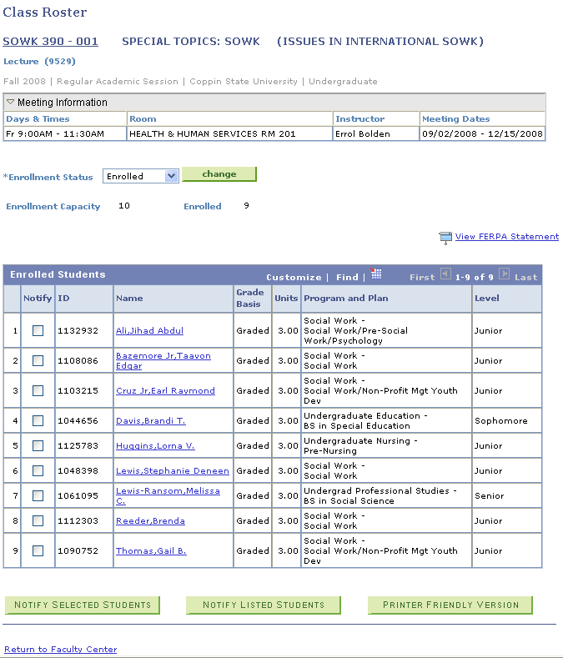 | - If there are multiple meeting patterns, they will display in the Meeting Information.  - If students have dropped classes, you will be able to select which Enrollment Status you wish to view. Choices are:  - Enrolled  - Dropped  - Both  - Click if you alter the Enrollment Status from the default.
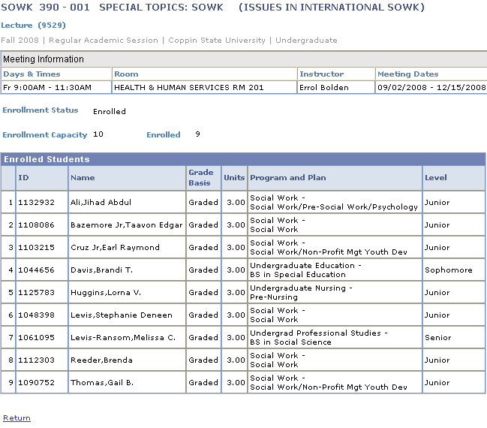 | - Press to return to manage other functions on the roster page such as to:  - Notify selected students  - Notify listed students  - Printer Friendly Version
 | - Press Return to Faculty Center to continue with other functions.

