Navigation:
Self Service > Student Center

Page | Action(s) to be taken
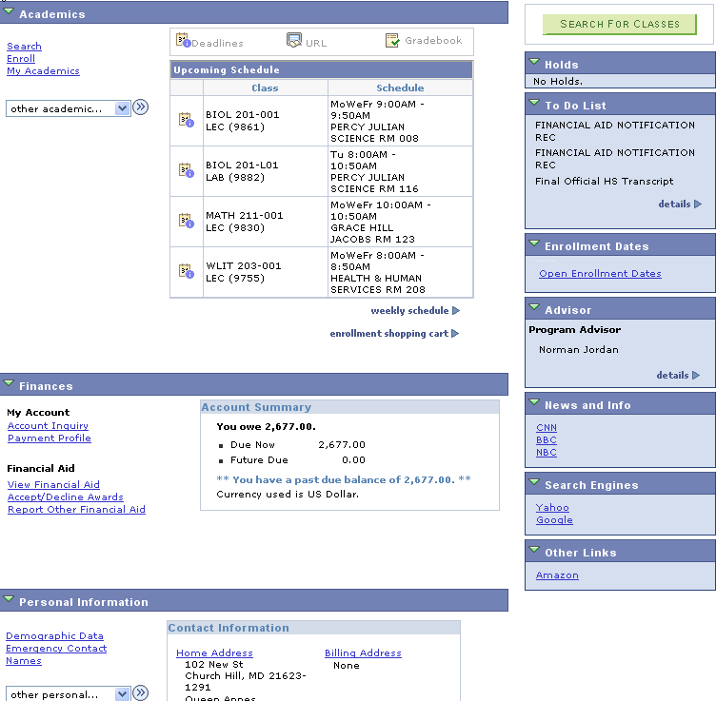  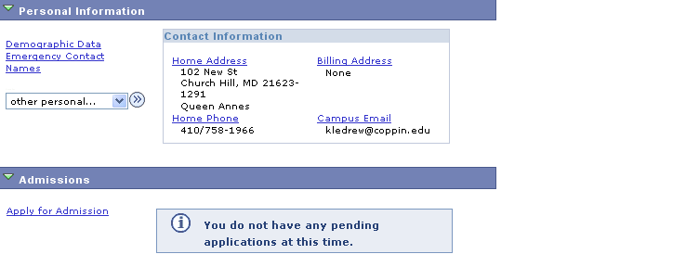 | - Click Home Address link in the Personal Information section.
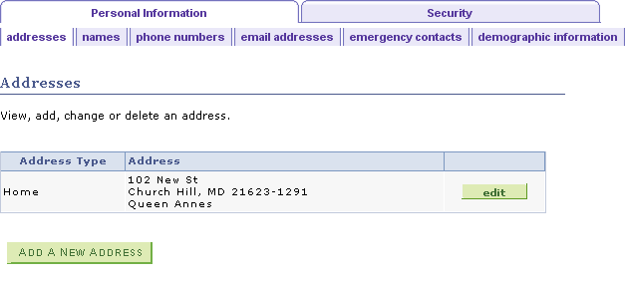 | - Click .
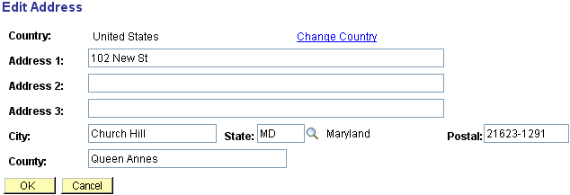 | - Change address as appropriate.
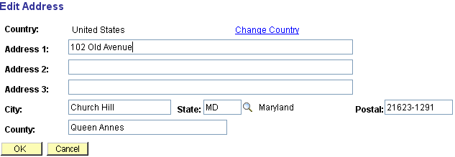 | - Click when all changes have been made.
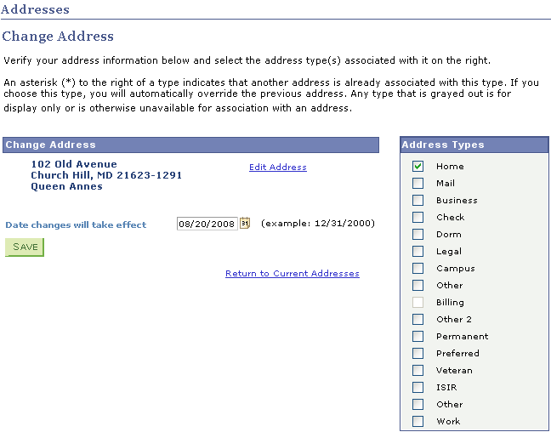 | - Validate that the address displayed is correct. If it requires more changes, click and proceed as in steps 3 & 4.  - Click .
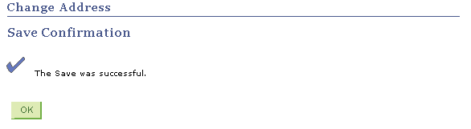 | - You will receive a message confirming that the updated data has been saved.  - Click

