Navigation:
Self Service > Student Center

Page | Action(s) to be taken
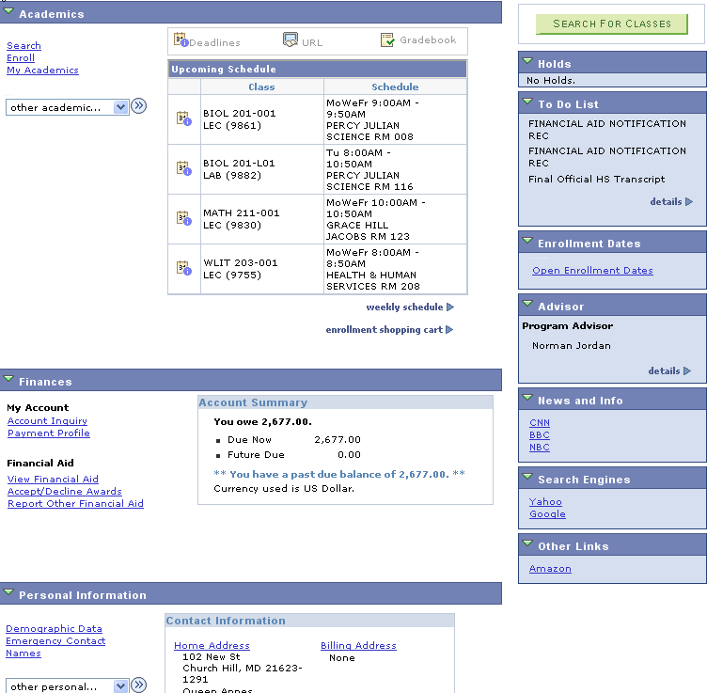 | - Click Enroll link.
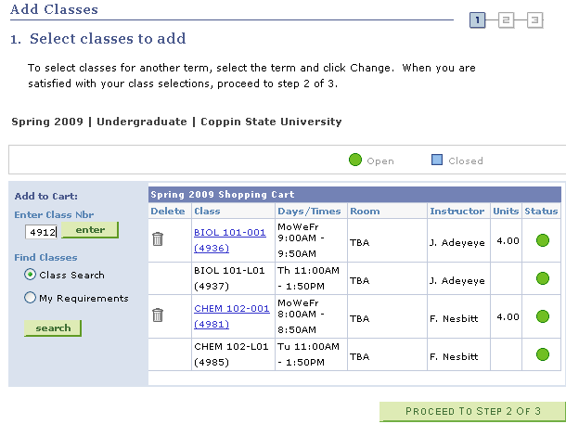 | - Enter a Class Nbr on the Select classes to add page.  - Click
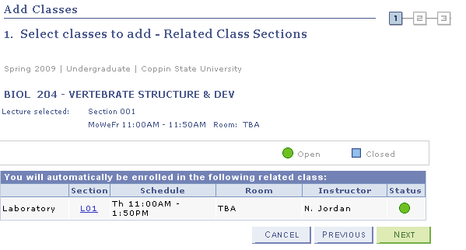 | - Review the results on the Select classes to add – Related Class Sections page.  - Click.
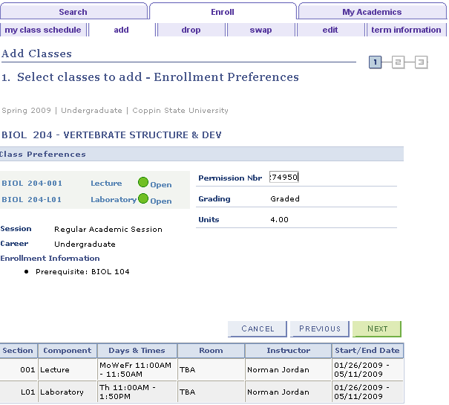 | - Review the preferences on the Select classes to add – Enrollment Preferences page.  - If you have a Permission Nbr, enter it on this page.  - Click.
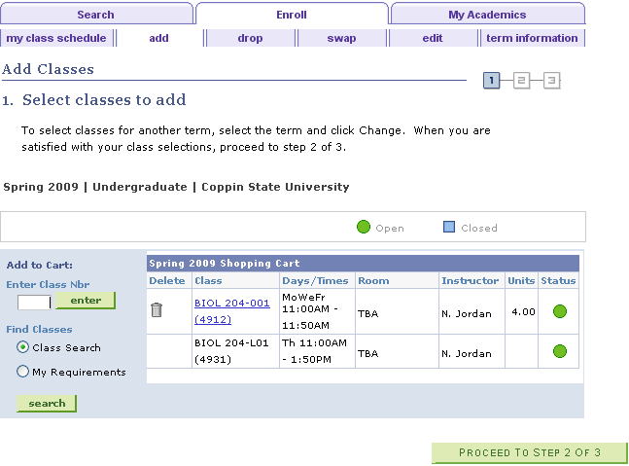 | - Click
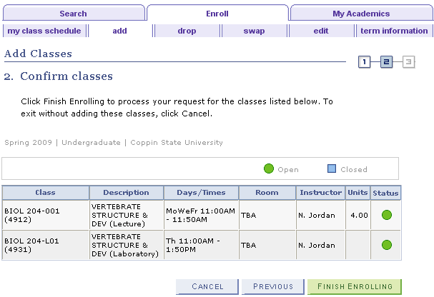 | - Confirm classes page displays the list of classes in your Shopping Cart for validation.  - Click to add the classes.
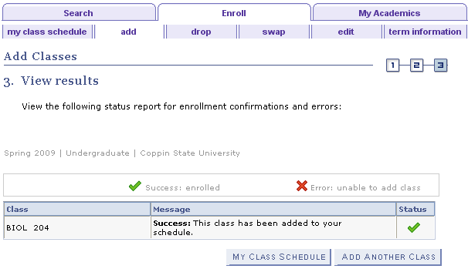 | - View Results page displays the status of your enrollment requests. In this case, the status = (Success) because the Permission Nbr overrode the requisites.  - Click to display your current class schedule.  - Click to add another class.

