Navigation:
Self Service > Student Center

Page | Action(s) to be taken
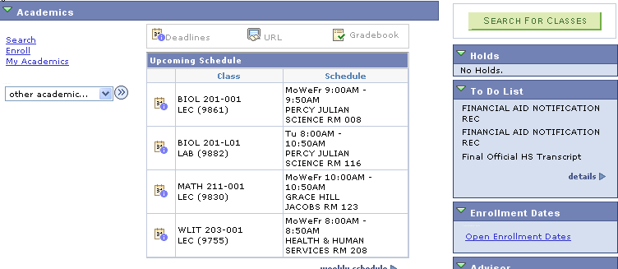 | - Click Search link.
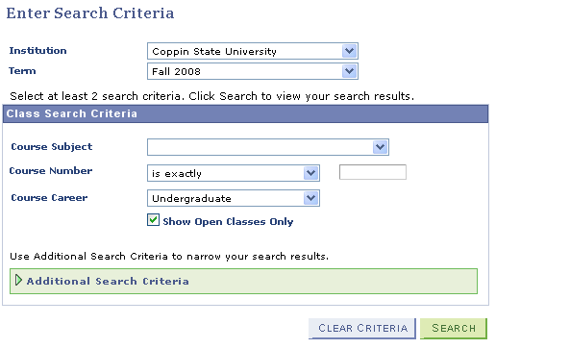 | - Enter Search Criteria page includes:  - Institution - Coppin State University defaults  - Term – Current Term defaults. You can alter the term by choosing from the available terms in the drop down list.  - Course Subject – (optional) select a subject from the drop down list  - Course Number – (optional) select options from the drop down list. Choices are:  - blank  - contains  - greater than or equal to  - is exactly  - less than or equal to  - Course Career - (optional) student’s Career defaults. You can select an alternative Career or leave blank for a larger selection of courses.  - Show Open Classes Only –defaults as checked. It is recommended that you leave it checked  - If you click without refining the search criteria a warning message will display.
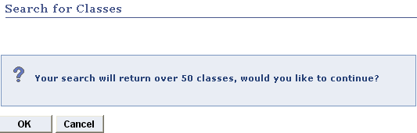 | - If you click , the system will take a long time to present all scheduled classes for the term. It is recommended that you click . This action will return you to the search criteria page to refine the search criteria.
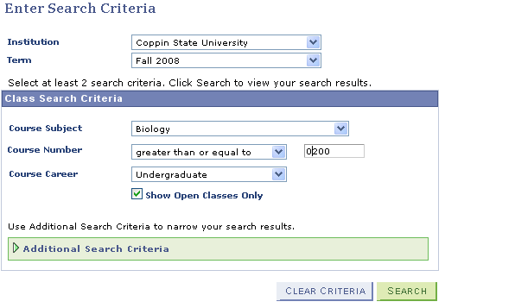 | - Enter at least 2 search criteria.  - To further refine your search, click
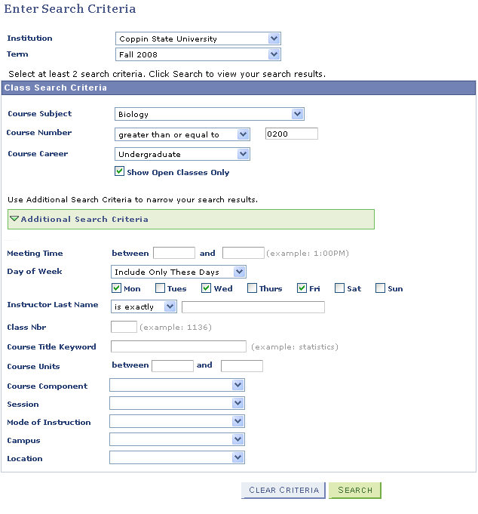 | - The search criteria you have entered copies forward to this page. You can refine criteria for :  - Meeting Time  - Days of Week specification  - Instructor Last Name specification  - Class Nbr  - Course Title Keyword  - Course Units  - Course Component  - Session  - Mode of Instruction  - Campus  - Location  - Click
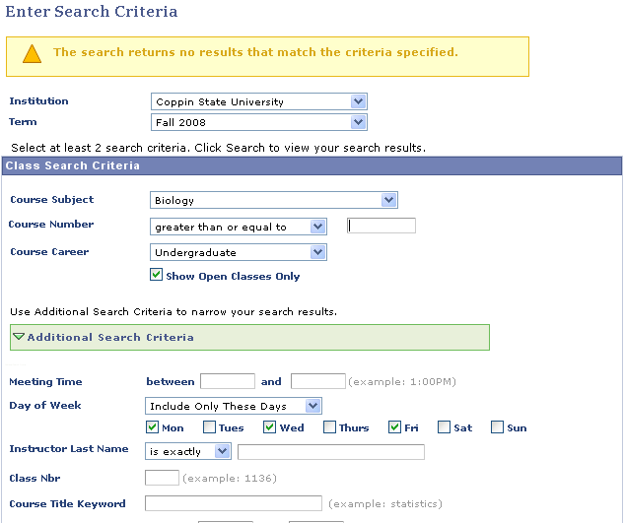 | - If you have restricted the search too much, you will receive an error message and be returned to the Search Criteria page to modify requirements.  - Remove/change a requirement.  - Click
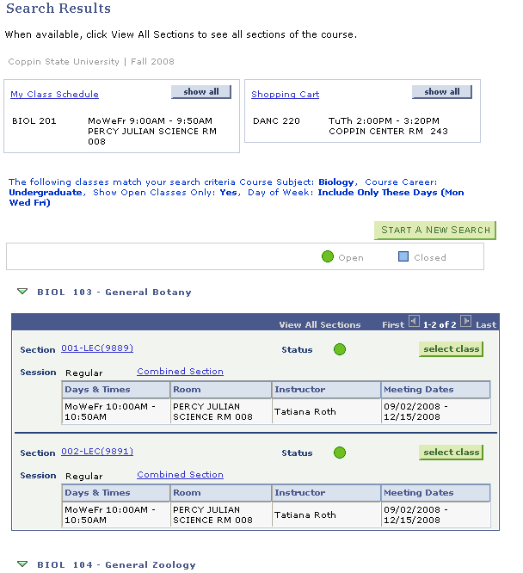 | - Only courses that satisfy the search criteria display in the Search Results page.  - If Class Schedule exists click  - If Shopping Cart exists click  - Compare classes in schedule & shopping cart to available sections from class search and select a section that has no time conflicts.  - Click to add to your Shopping Cart.
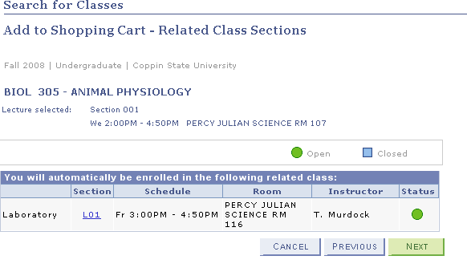 | - Add to Shopping Cart – Related Class Sections page displays.  - Click to halt add to shopping cart.  - Click to return to the previous page.  - Click to review class enrollment details.
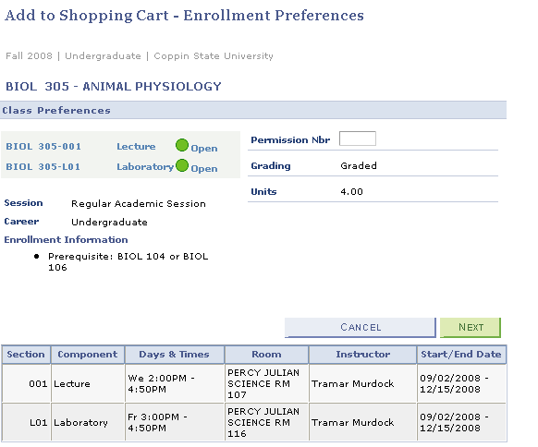 | - Add to Shopping Cart – Enrollment Preferences page displays.  - Click to halt add to shopping cart.  - Click to complete addition to shopping cart.
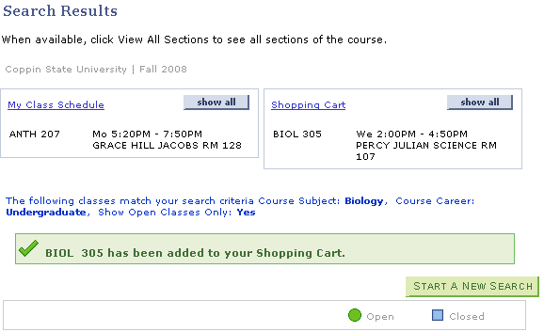 | - A message appears on the Search Results page to inform you that the selected course has been added to your Shopping Cart.  - Click to continue selecting courses to add to the shopping cart.

